**Laboratory Experiment 2: Speed Control Experiment**

MTRN3020 Modelling and Control of Mechatronic Systems

I verify that the contents of this report are my own work.

Evan Darmanin

z3251862

21st September 2012

Contents

1. Introduction 2

2. Aim 2

3. Procedure 3

4. Controller Design 4

5. Simulink Block Diagram of the Experiment 6

6. Part A - No Load 7

7. Part B – Variable Load 7

8. Conclusion 10

# Introduction

This experiment refers to the design and implementation of a speed controller of a motor experiencing a variable load. This experiment is about providing students with an experience in designing a controller from a set of design specifications. The experiment involves predicting controller performance and comparing to actual results obtained through implementation of the designed controller to give students feedback on how successfully their controllers performed.

# Aim

The aim of this experiment is to verify whether a designed controller functions correctly in reality compared to expected performance.

# Procedure

The experiment involved students inputting controller parameters into a computer and instructing the computer to run the motor. The motor was required to rotate at a specific speed. This was verified by two stages of testing, one under constant load and a second under variable load.

This experiment required students to first prepare calculations using the direct analytical design method given certain design specifications. For this particular experiment the specifications were a sampling time of 5ms and a design Tau value of 32ms.

When calculations had been made the student input their unique values into the computer and began the first stage of the motor test where under zero load the motor was required to rotate at 1000rpm. A second stage moved the desired speed to 2000rpm.

The second test simulated variable load through the use of a generator with variable current applied to it to induce different levels of torque (mechanical resistance) on the motor. The combination of different resistors allowed the current in a generator to vary and the applied load on the motor to fluctuate. The motor was required to rotate at 2000rpm.

The motor’s speed was measured and recorded for the duration of the test. The output of the computer was made available for analysis of the performance of the controller.

# Controller Design

The unique design tau time is 32ms. The sample time is 5ms.

Start by attaining a FOA to the zero load/open loop results:

By utilizing the lsqcurvefit function MATLAB offers, we can fit a curve to the zero load data to find the values of $τ$ and *A*.:

$y\left(t\right)=A\left(1-e^{-\frac{t}{τ}}\right)$,

x = lsqcurvefit(@myfun,[750000,0.04],time,speed)

A = 7.5809e+005;

tau = 0.0371;

By substituting in these values and introducing an integrator, the voltage/counts transfer function is determined as

$$G_{p1}\left(s\right)= \frac{A}{1+τs}$$

$$A=\frac{7.5809 ×{10}^{5}}{24}=31587$$

$$Gp\left(s\right)= \frac{24A}{4.669s^{2}+ 126τs} OR = \frac{758090}{24}. \frac{24}{126}.\frac{1}{s\left(1+0.03702s\right)}$$

$$Gp\left(s\right)= \frac{6016.5873}{s(1+0.0367s)}$$

By creating appropriate variables and utilizing the following MATLAB functions finds a discrete version of the continuous TF, which allows for *Gp(z)*. to be formed:

num = 6016.5873

den = [tau 1 0];

= [0.03702 1 0];

sampleT = 0.009;

[numd, dend] = c2dm(num,den,sampleT,’zoh’);

The roots of numd produce the numerator of A(z) likewise the roots of dend help form the denominator:

$$A\left(z\right)= \frac{6.0769(z+0.92218366)}{(z-1)(z-0.7842)}$$

Gp(z) can then be established by immediate substitution as:

$$Gp(z)= A\left(z\right)\frac{(z-1)}{zT}$$

$$Gp(z)= \frac{6.0769(z+0.92218366)}{0.005(z)(z-0.7842)}$$

Utilizing the personalized time constant value provided on moodle and requiring a zero SSE, which is unity DC gain, then $F\left(z\right)=1$. As the zero has the potential to result in ringing, the numerator needs to take in its value. Since $s= -1/τ_{d}$, the placement is then $e^{-T/τ_{d}}$. To form F(z) we use:

$$F\left(z\right)= \frac{(1-e^{-\frac{T}{τ_{d}}})}{(1-z_{1})}\frac{(z-z_{1})}{(z-e^{-\frac{T}{τ_{d}}})}$$

Hence:

$$F(z)=\frac{bo (z-z1)}{z(z-e^{T/Td})}$$

And so due to the ringing caused by the zero in the numerator of Gp(z):

$$F(z)=\frac{bo (z+0.92218366)}{z(z-0.8222982)}$$

If F(1) = 1*:*

$$F\left(1\right)=1=\frac{bo \left(1.92218366\right)}{(0.1777018)} , bo=\frac{ 1(0.1777018)}{(1.92218366)}=0.07397$$

***I have detected a mistake here in my original working (bo = 0.0756)

$$F(z)=\frac{0.07397 (z+0.9560)}{z(z-0.8553)}$$

 ***

To calculate Gc(z):

$$Gc(z)=\frac{1}{Gp\left(z\right)}\frac{F(z)}{(1-F\left(z\right))}$$

$$Gc(z)=\frac{ 0.005}{1.9414}\frac{ (z)}{(z)}\frac{ (z-0.8738)}{(z-0.8553)}\frac{ (z+0.9560)}{(z+0.9560)}\frac{ (0.07397)(z)(z-0.8553)}{z\left(z-0.8553\right)- 0.07397(z+0.956)}$$

$$Gc(z)=\frac{ (1.9051×{10}^{-4})(z^{2}-0.8738z)}{z^{2}-0.9293z-0.07072}$$

where the roots of the numerator are 0 and 0.8378.

The roots of the denominator are 1.000 and -0.07072

***Comparing this to my original calculations these are quite close however the roots of the denominator were 1.003 and -0.07204, indicating the error. ***

The controller then can be written with the difference equation:

5. Simulink Block Diagram of the Experiment

This diagram below (fig.1) shows the experiment as simulated using Simulink.

$$Gc(z)=\frac{ (1.9051×{10}^{-4})(z^{2}-0.8738z)}{z^{2}-0.9293z-0.07072}$$

Fig. 1

* No load block diagram

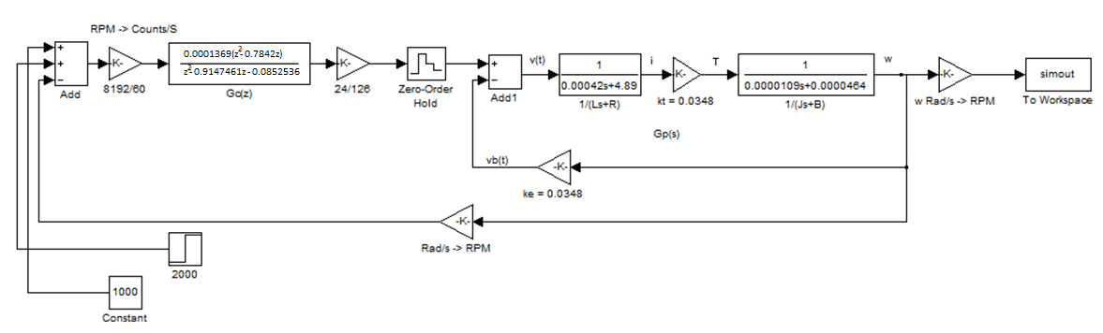

# **6. Part A - No Load**

The following plot (fig. 2) is the output of the block diagram from figure 1 overlayed onto experimental data. It shows the correlation between the experimental data and the predicted data from the modelling of the motor controller.

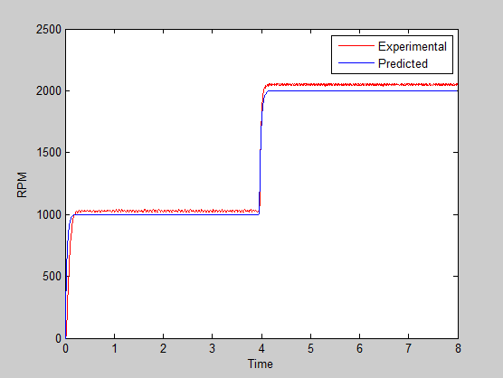

Fig.2 - Performance Graph

Experimental vs. predicted data

This plot shows that the design is correct, the experimental results closely match the predicted results. There is some stationary error, very fast rise time and no overshoot.

# 

# **7. Part B – Variable Load**

Using the dec2hex(3251862)function in MATLAB yields hex number 319E96.

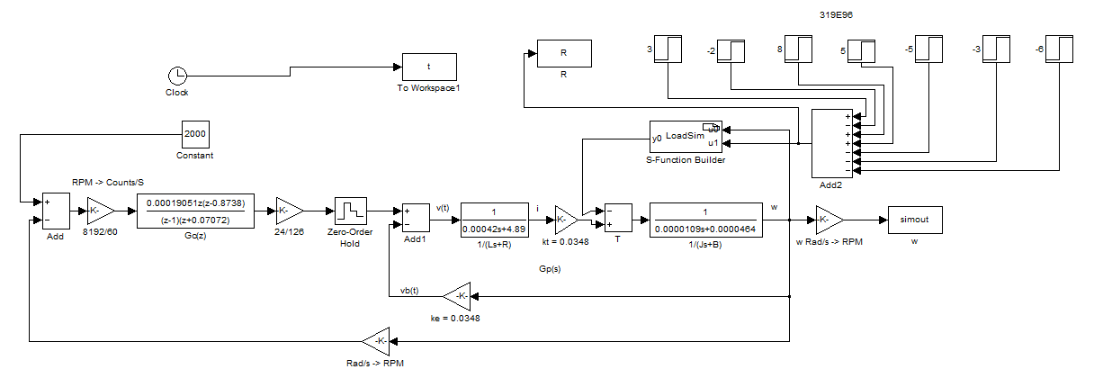The LoadSim block allows us to connect a ‘Load Torque’ to the motor’s speed. By introducing a number of resistors equal to the hex student number as shown in the following diagram (Fig. 3) we can vary the load to the motor to simulate the varying load as it was in the experiment.

Fig.3 – Load Performance Graph

Experimental vs. predicted data

The following plot (Fig. 4) is the output of the block diagram from figure 3 overlayed onto the experimental data. It shows the correlation between the experimental data and the predicted data from the modelling of the motor controller.

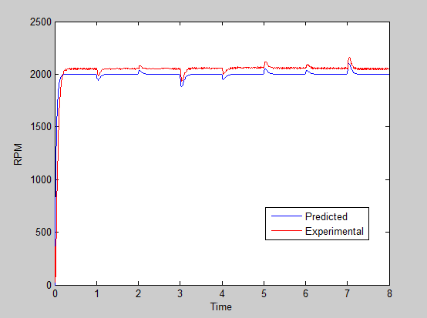

Fig.4 – Load Performance Graph

Experimental vs. predicted data

This plot shows that the design is correct, the experimental results closely match the predicted results. There is some stationary error, fast rise time and no overshoot.

# 8. Conclusion

One will notice from Figure 2 and Figure 4 that the predicted and experimental plots do not match up exactly, rather there is a stationary error. This can in part be attributed to the calculation errors highlighted on page 5 of the controller design calculations which indicate that the experimental controller was not correct at the time of testing. Hence we the red experimental line is incorrect, but now with the revised calculations should be rectified.

In regards to the stationary error, this is most likely caused by the incorrect controller but may also be due to a physical effect. We would have expected a zero steady state error for a properly functioning controller. Given that the feedback loop only features a proportional gain, and no integrating component any stationary error caused by a difference between actual and desired speed will not reduce over time. Hence performance could be improved by including an integrator in the feedback loop to eliminate stationary error.

Other errors that may have contributed to the difference between expected and actual results includes the true vs. theoretical the values of plant parameters. Armature resistance, armature inductance, motor inertia, viscous damping, torque constant, and back EMF constants may have been slightly different during the test. This discrepancy would change the plant transfer function slightly and contribute to a difference between expected and measured results.

In essence the controller is valid in terms of its ability to maintain a steady control, albeit with some stationary error. Calculation errors have been detected and rectified and thus one can expect the designed controller to perform more accurately in the future.

We can see that in both figure 4 and especially figure 2 the rise time is fast. The system exhibits characteristics of overdamping, and there is no overshoot, which are desirable performance characteristics for a motor application. The motor controller is shown to reasonably accurately follow the desired speed, even with varying load such that desired speed is reached in less than 0.1 of a second. This settling time appears to be more than satisfactory for a simple mechanical system and hence one can conclude that this motor control design experiment has been successful.